Rotary Club of Conifer Foundation
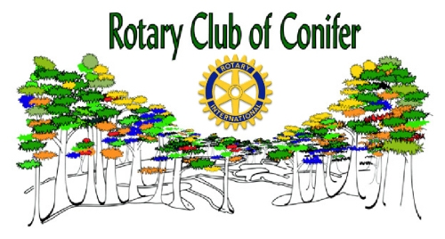

Grant Application

Application Deadline: Sept. 16, 2016
____________________________________________________________

Program Area:

___ Arts & Culture ___ Children, Youth & Families
___ Vocational ___ Community Services

Type of Support Requested:

___ Event Sponsorship ___ Funding a Specific Program
___ General Operations ___ Capital

Amount of Request: _________ Total Current Operating Budget: __________

Organization Information:

Name of Organization: ______________________________ Tax ID# __________

Street Address: ____________________________________________

City: __________________________ County: _____________________

State: ________________________ ZIP: ________________________

Telephone: ____________________ Fax: ________________________

E-Mail: ___________________________ Web site: ____________________

Number of full-time employees (Combine part-time employees so that 40 hours/week equals one full-time employee): ________

Name of Primary Contact: __________________ Title: _______________________

If Applicable:

Name of Project or Event: _____________________________________________

Total Project / Event Expenses: __________________________________________

Date(s) of Event (or start of project): _____________________________________

Please answer the following questions, use additional pages if needed:

- What is your mission statement?

- What need(s) will you be fulfilling in the community as a result of this grant?

- Describe the event or program for which you are requesting funds.

- How many people do you expect to attend your event (if applicable)?

- How many people will be directly served by your organization this year? If the funding request is for a specific program, how many people will be directly served by it?

- What are the measurable outcomes (results) that you expect your programming or events will have on those being served? Who will benefit from your work? What specific change in condition or behavior will they experience? How long will it take to see benefit from this program and how long do you expect this benefit to last? How will you measure and evaluate the change and the program’s overall effectiveness?

- What portion of the funds requested will be applied directly to the program or event?

- What donor recognition will the Rotary Club of Conifer Foundation receive if this grant request is approved?

Signature of Applicant: _________________________________________________

Title: ____________________________________ Date: _________________

Continued on next page

Required Attachments:

- Current operating budget including income and expenses. (If less than 90 days remain in your current operating budget, please submit the proposed budget for the next fiscal year.)

- Most recent year-end financial statement.

- If applicable, the event or program budget including expected income and expenses.

- If applicable, event or program sponsorship levels.

- List of your board of directors and their occupations / community affiliations.

- IRS 501(c) (3) determination letter.

- Repeat grant requests must include their final report (or interim report if a multi-year project) including narrative, financial summary, and donor recognition for the most recent grant, if not already submitted.

Submit Completed Application and Supporting Material to:

Rotary Club of Conifer
PO Box 1430
Conifer, CO 80433
ATTN: Wendy Woodland

Electronic Applications to:
Wendy Woodland at: twendy24@hotmail.com

______________________________For Rotary Use Only ______________________________

Approved / Denied / Countered: __________________________________________________________

Rotary Club of Conifer Foundation President: _____________________________ Date: ______________

